Task 2. – to learn social intelligence as a base on non-verbal communication’ success. Do the Subtests 1, 2 and 4 from Guildford’s "Social intelligence" Test and write an essay basing on your results.

NB! Read attentively every task in Subtests on the next pages. Write everything in the Answer Form. Circle those answer which you consider correct in the Answer Form.

Answer Form

Name_____________________________________________ Date ____________

Age _______________ Gender ____________ Group Number ____________

 | Subtest 1 | Subtest 2 | Subtest 4
1 | 1 2 3 | 1 2 3 4 | 1 2 3 4
2 | 1 2 3 | 1 2 3 4 | 1 2 3 4
3 | 1 2 3 | 1 2 3 4 | 1 2 3 4
4 | 1 2 3 | 1 2 3 4 | 1 2 3 4
5 | 1 2 3 | 1 2 3 4 | 1 2 3 4
6 | 1 2 3 | 1 2 3 4 | 1 2 3 4
7 | 1 2 3 | 1 2 3 4 | 1 2 3 4
8 | 1 2 3 | 1 2 3 4 | 1 2 3 4
9 | 1 2 3 | 1 2 3 4 | 1 2 3 4
10 | 1 2 3 | 1 2 3 4 | 1 2 3 4
11 | 1 2 3 | 1 2 3 4 | 1 2 3 4
12 | 1 2 3 | 1 2 3 4 | 1 2 3 4
13 | 1 2 3 | 1 2 3 4 | 1 2 3 4
14 | 1 2 3 | 1 2 3 4 | 1 2 3 4
15 |  | 1 2 3 4

Subtest No. 1 "Stories with completion"
In this subtest you will deal with pictures that depict the everyday situations that occur with the character Barney. Barney is a bald man, by profession - a waiter. In situations, the wife, the young son and friends of Barney, with whom he meets at home or in a cafe, also take part.
In each task on the left is a picture depicting a particular situation. Identify the feelings and intentions of the characters in it and choose among the three pictures on the right the one that shows the most plausible option for continuing (completing) this situation.
Consider an example:
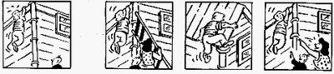
In the picture on the left, Barney, hooked to the edge of the roof, is frightened and asks for help from his young son. The boy is excited to see his father in such a difficult situation.
The choice of Figure No. 1 is the correct answer in this case. Therefore, on the Answer Form, the number 1 is circled. Figure number 1 is the most logical and plausible continues the given situation: the wife and son Barney put a ladder to the wall in order to help him go down.
The choice of Figures 2 and 3 is less correct. As for drawing number 2, it is unlikely that, hanging in the air in such a frightened and helpless state, Barney will be able to climb onto the roof himself. Since Barney's position is dangerous, the wife and son would hardly mock him, as shown in figure 3.
So, in each task, you must predict what will happen after the situation depicted in the left figure, based on the feelings and intentions of the characters in it.
Do not choose a picture to answer only because it seemed to you the most amusing continuation. Offer the most typical and logical continuation of the given situation. The number of the selected figure (indicated in the lower right corner of the figure) is circled in a circle on the Answer Form. In the test notebooks, you can not make any notes.
Subtest is given for 6 minutes. A minute before the end of the work you will be warned. Work, if possible, faster. Do not waste much time on one task. If you are at a loss, answer the next question. To difficult tasks it will be possible to return at the end, if there is time. In difficult cases, give an answer, even if you are not entirely sure of its correctness.
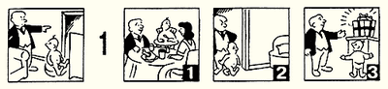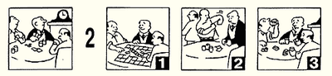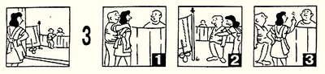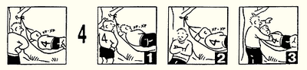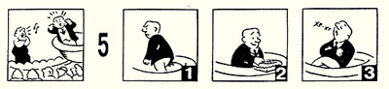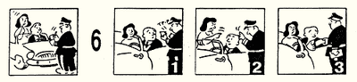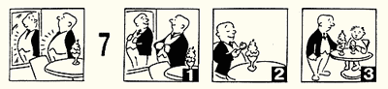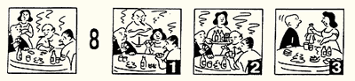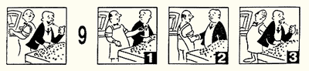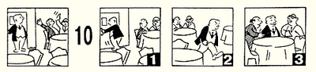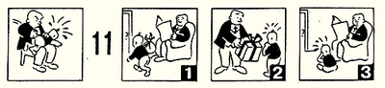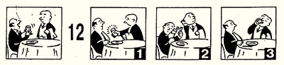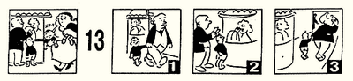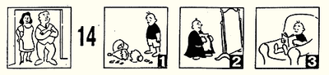

Subtest No. 2 "Group expression"
In this subtest you will deal with pictures that depict poses, gestures, facial expressions, that is, expressive movements that reflect the state of a person.
To explain the essence of the task, consider an example. In this example, the three pictures on the left illustrate the same state of a person, the same thoughts, feelings, intentions.
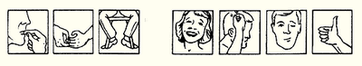
One of the four pictures on the right expresses the same state, the same thoughts, feelings, or intentions. It is necessary to find this picture.
The correct answer is Figure 2, which expresses the same state (tension or nervousness) as the pictures on the left. Therefore, on the Answer Blank, figure 2 is circled. Figures 1, 3, 4 are not suitable, because they reflect other states (joys and well-being).
So, in each task subtest among the four drawings on the right You should choose the one that fits the group of three figures on the left, because it reflects a similar state. The number of the selected pattern with the circle in the form of responses.
On the execution subtest is given 7 minutes. A minute before the end of the work You will be warned. Work, if possible, faster. Don't waste a lot of time on one task. If difficult to answer, skip to the next paragraph. Difficult tasks can be revisited at the end, if you have the time. In difficult cases, let's answer, even if not completely sure it is correct.
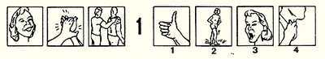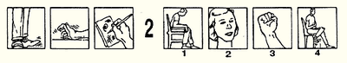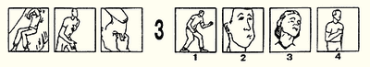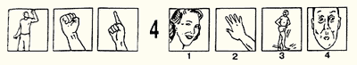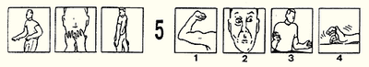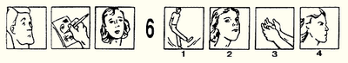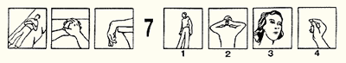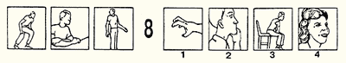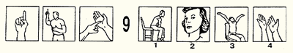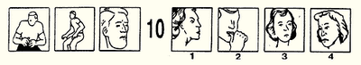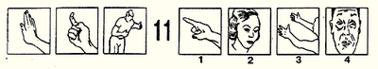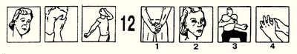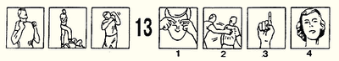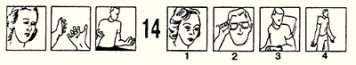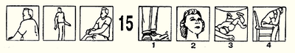

Subtest No.4 "History Supplement"
In this subtest You will be dealing with pictures, which depict the story of Ferdinand. The Ferdinand has a wife and small child. He works as a chief, so the stories will also participate his colleagues.
Each task consists of eight pictures. The top four pictures reflect a history, originating with Ferdinand. One of these pictures is always ignored. You have to choose among four pictures the lower the number, which after the substitution in place of the empty square at the top will complement the story of Ferdinand in meaning. If You correctly choose the missing figure, the sense of history will be fully clarified, feelings, and intentions of currently active characters will become clear.
Consider this example:
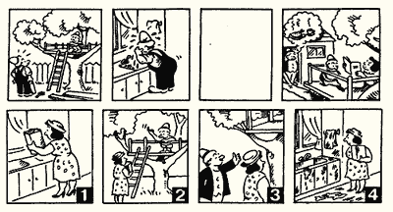
In this story there is no third picture. At the end of history, we see that Ferdinand, who dreamed about lunch, not getting it, contrary to its expectations and comes out annoyed. Wife of Ferdinand angry and pretends to read her son's book. The boy sits quietly. All this is due to the fact that Ferdinand, washing up after work, left the kitchen dirt, and that angered his wife. Thus, a logical addition to the story is figure # 4. Therefore, in the form of responses figure 4 circled.
Drawings No. 1, 2, 3 do not correspond to the story meaning.
So, in each task you need to find a picture that complements the story of Ferdinand in meaning. On the execution subtest is 10 minutes. A minute before the end of the work You will be warned. Work, if possible, faster. Don't waste a lot of time on one task. If difficult to answer, skip to the next paragraph. Difficult tasks can be revisited at the end, if you have the time. In difficult cases, let's answer, even if not completely sure it is correct.

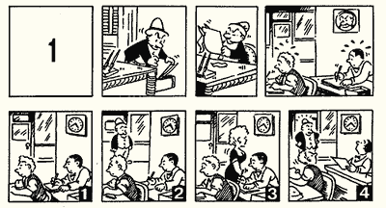
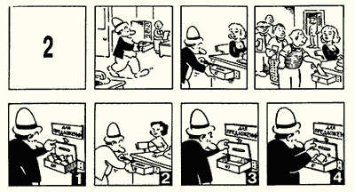
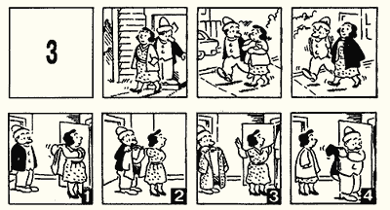
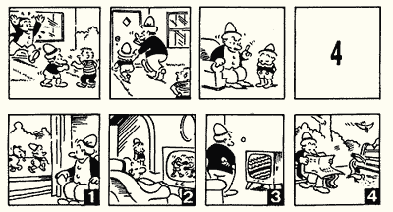
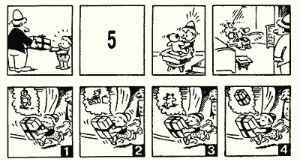
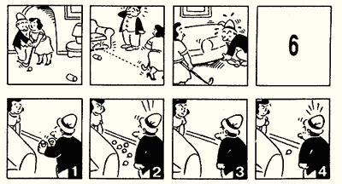
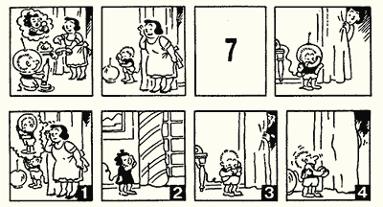
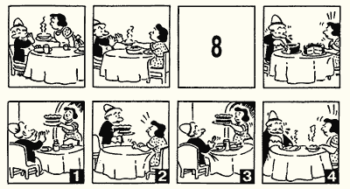
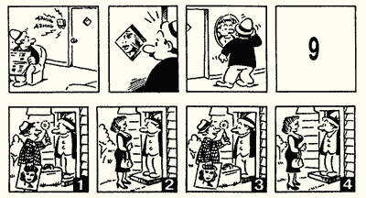
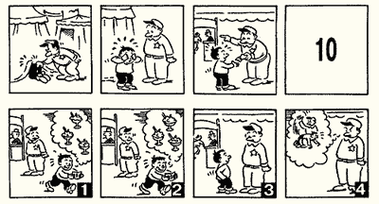
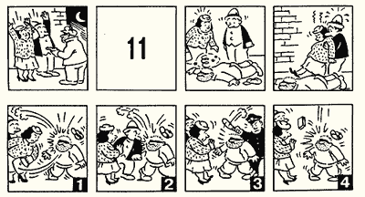
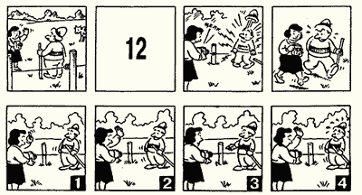
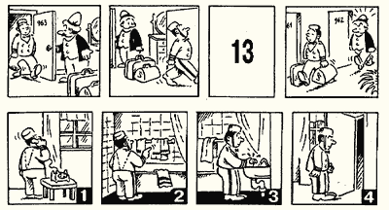
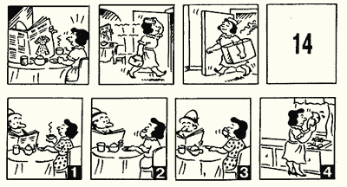

The key to processing the method

Correct answers:
№ | Subtest 1 | Subtest 2 | Subtest 4
1 | 2 | 1 | 4
2 | 2 | 4 | 3
3 | 2 | 3 | 3
4 | 3 | 3 | 2
5 | 1 | 2 | 1
6 | 3 | 1 | 1
7 | 3 | 2 | 4
8 | 3 | 2 | 1
9 | 3 | 1 | 1
10 | 3 | 4 | 2
11 | 3 | 1 | 1
12 | 1 | 1 | 2
13 | 1 | 2 | 2
14 | 2 | 4 | 1
15 |  | 4

Normative tables for determining standard score (for the age group 18-55 years)

standard score | Subtest
 | 1 | 2 | 4
1 low | 0 – 2 | 0 – 2 | 0 – 1
2 below the average | 3 – 5 | 3 – 5 | 2 – 4
3 average | 6 – 9 | 6 – 9 | 5 – 8
4 above the average | 10 – 12 | 10 – 12 | 9 – 11
5 high | 13 – 14 | 13 – 15 | 12 – 14

Write an essay (up to 2000 characters) basing on your results and answer next question:
- What level of each of the abilities’ development do you determine?
- What are the results obtained? Please, carry out a meaningful interpretation of each result (S. 1 – ability to foresee the consequences of their behavior;
S. 2 ability to correctly estimate the state, feelings, people's intentions for their non-verbal expressions, facial expressions, postures, gestures;
S. 4 ability to recognize the structure of interpersonal situations in dynamics).
- What role does social intelligence play in people’s communication?

